Literacy support worksheet

2.1 Rocks have different properties

Pages 18–19 and 140

Rock properties

1 Match the rock to its correct properties:

|  |  |
| --- | --- |
| SW0213_00951-r  Conglomerate | Fine grain, soft, light colour |
| SW0202_00951-r  Pumice | Fine grain, soft, dark colour |
| SW0203_00951-r  Basalt | Coarse grain, crystals in layers |
| Quartzite | Mixed grain, hard or soft, colour varies |
| SW0205_00951-r  Marble | Medium to coarse grain, layers, splits easily |
| SW0206_00951-r  Rhyolite | Fine or mixed grain, dark colour |
| SW0207_00951-r  Coal | Coarse grain, hard, light colour |
| SW0209_00951-r  Schist | Coarse grain, soft, light colour |
| SW0216_00951-r  Gneiss | Fine grain, often larger crystals, light colour |

2 What does the word ‘density’ mean?

3 Why are rocks different colours?

4 How can you identify rocks? Use an example.

5 List three ways crystals are different to grains.

a

b

c

6 Who am I? Use Table 2.1 and Figure 2.6 on p 19 of *Oxford Science 8* to name the following rocks:

a I am dark in colour. I am soft and have a fine grain size. Some say I look like black glass.

b I have a coarse grain. I am soft and light in colour. Sometimes I look pink and other times I look white.

c I am fine-grained, have larger crystals and am light in colour. I am also very hard, with approximately one and a half times the density of water.

Word detective

7 Matching meaning

Match the words (on the left) with the correct descriptions (on the right).

**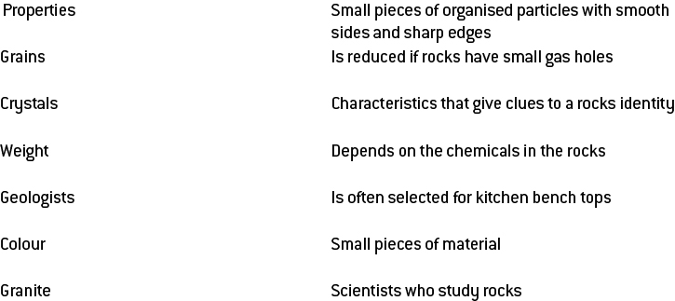**

Literacy support worksheet

2.2 Rocks are made up of minerals

Pages 20–21 and 160

Classifying minerals

1 What is a mineral?

2 How are minerals found?

3 If graphite and carbon are both made of pure carbon, why do they look different?

4 There are six characteristics that can be used to classify rocks. Briefly, in only a few words, explain each one.

a

b

c

d

e

f

5 What is the Mohs scale?

6 Explain how Mohs knew that diamond was harder than talc.

7 What are the three cleavage planes?

a

b

c

8 Create a dichotomous key to identify the seven rocks below using the properties of rocks and minerals on pages 18–21 of *Oxford Science 8*. The key has been started for you.

|  |  |  |  |  |  |  |
| --- | --- | --- | --- | --- | --- | --- |
| SW0217_00951 | SW0218_00951 | SW0219_00951 | **SW0220_00951** | **SW0221_00951** | **SW0222_00951** | **SW0223_00951** |
| Diamond | Quartz | Apatite | Amber | Fluorite | Pyrite | Sulfur |

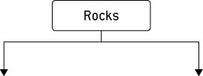

Word detective

9 Boggle

Find as many words as you can in the puzzle below.

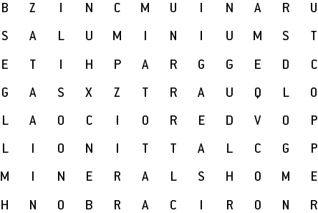

Literacy support worksheet

2.3 Minerals are a valuable resource

Pages 22–23 and 161

Minerals as resources

1 What is an ore?

2 When and where was gold first discovered in Australia?

3 Gold has always been a resource in demand. Name four uses for gold:

a

b

c

d

4 Australia is one of the world’s biggest producers of aluminium. Take-away food is often served in aluminium containers. What are three properties of aluminium that make it useful?

a

b

c

5 Why is it important to recycle aluminium?

6 Which minerals are found in mobile phones?

7 How does recycling the minerals in mobile phones help the ecosystem in the Congo?

8 What form is copper in when it is mined in Australia?

9 Name three uses for copper:

a

b

c

Word detective

10 True or false

Read the statement and circle whether it is true or false.

a Minerals are renewable resources. T or F

b Australia is rich in mineral resources. T or F

c Copper was the first metal to be used by humans. T or F

d The minerals in mobile phones cannot be recycled. T or F

e Mining in the Congo is threatening gorilla habitats. T or F

f Silica mined from sand is found in toothpaste. T or F

g Mineral sands are old beach sands. T or F

h Minerals are in high demand in China. T or F

i Granite is found in toothpaste. T or F

j Recycling aluminium leads to reduced greenhouse gases. T or F

k Copper is used as fillings for teeth. T or F

l The demand in copper is predicted to rise. T or F

m Gold was discovered in Australia in the 1820s. T or F

Literacy support worksheet

2.4 Igneous rocks develop from magma and lava

Pages 24–25 and 162

Igneous rocks

1 What does the term ‘igneous’ mean?

2 What material is used to form an igneous rock?

3 Circle the correct answer. Lava forms:

a on the surface of the Earth as extrusive igneous rock.

b below the Earth as intrusive igneous rock.

4 Complete the following table to summarise the main differences between the formation of extrusive and intrusive igneous rock.

|  |  |  |
| --- | --- | --- |
|  | Extrusive Igneous Rock | Intrusive Igneous Rock |
| Formed by lava or magma? |  |  |
| Formed inside or outside of the volcano? |  |  |
| Method of cooling  (quick or slow)? |  |  |
| How does it reach the surface of the Earth? |  |  |

5 What is the most common type of rock in the Earth’s crust?

6 Label the following diagram of a volcano:

**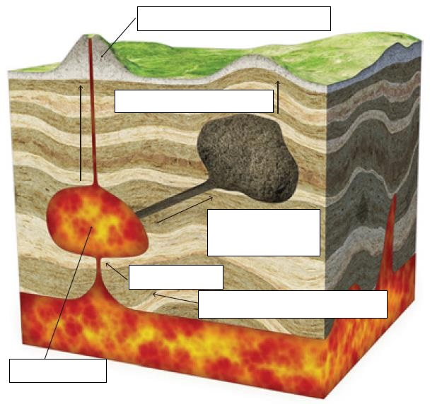**

Word detective

7 Mumbo jumbo

a Use the marked letters to find the secret word (e.g. olusntoi = solution).

b Unscramble each of the clue words to find the message.

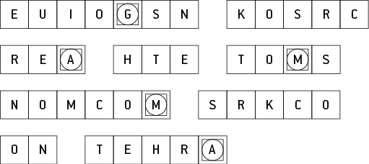

Secret word:

Message:

Literacy support worksheet

2.5 Sedimentary rocks are compacted sediments

Pages 26–27 and 163

Sedimentary rocks

1 How are sedimentary rocks formed?

2 What are sediments? Give an example.

3 Explain the formation of sedimentary rock by placing the following sentences in order to match the diagrams. Write ‘a’, ‘b’, ‘c’ or ‘d’ from the sentences below, beside the corresponding rock diagram.

a Chemicals that are dissolved in the water can soak into the sediments.

b Sediments are deposited in layers.

c The chemicals help cement the grains together once the water has evaporated.

d The grains of sediment in lower layers begin to squash together.

|  |  |
| --- | --- |
| SW0226_00951 |  |
| SW0227_00951 |  |
| SW0228_00951 |  |
| SW0229_00951 |  |

4 Complete the following list. Sedimentary rock can be formed from:

a

b

c

d

Word detective

5 Draw and label

Draw and label a diagram of how stalagmites and stalactites are formed using the following words:

dissolved limestone drips deposited stalagmite stalactite

|  |
| --- |
|  |

Literacy support worksheet

2.6 Metamorphic rocks require heat and pressure

Pages 28–29 and 164

Metamorphic rocks

1 How is metamorphic rock formed?

2 What does metamorphosis mean?

3 Why are metamorphic rocks so strong?

4 Research and label the following diagram of the rock cycle:

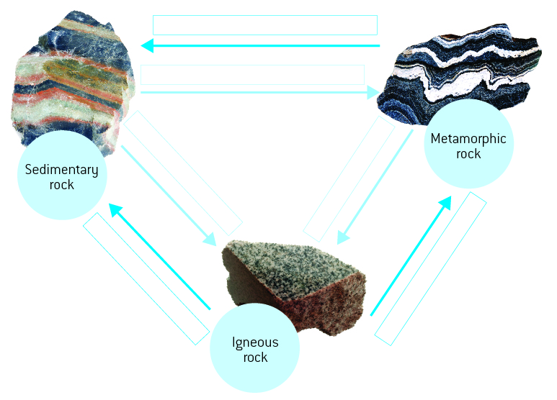

Word detective

5 Crossword

Read the clues and complete the crossword below.

|  |  |
| --- | --- |
| **Across**  3 How the three rock types change from one to another  5 Erupts from a volcano and forms igneous rocks  6 Worn away by weathering  10 Magma cools to form these rocks  11 The Taj Mahal is made out of this metamorphic rock  **Down**  1 Rocks formed from sediment  2 Created when other rocks are heated/squeezed  4 A sedimentary rock that is changed into slate  7 Marble is formed from this rock  8 Can be changed into gneiss with heat and pressure  9 A characteristic, quality or feature  11 It takes this many years for the rock cycle to take place | LS0207_00951 |

Literacy support worksheet

2.7 The rock cycle causes rocks to be re-formed

Pages 30–31 and 165

The rock cycle

1 What is weathering?

2 What is erosion?

3 What is onion-skin weathering?

4 Use the sentences below to fill in the gaps of the cycle that describe frost shattering.

a Water expands and pushes against crack in the rock

b Ice melts and water fills the crack again

c Water freezes in the crack of rock at night

d Crack becomes larger

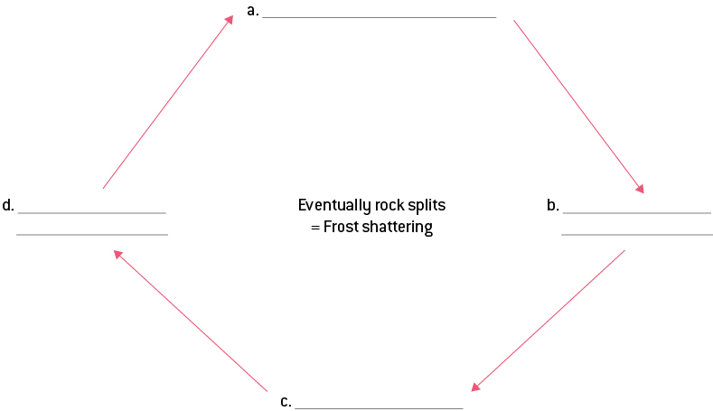

Word detective

5 Order us!

Put the sentences below in the correct order within the cartoon strip and illustrate.

* When the lava cools it hardens to become an igneous rock.
* The rock gets hotter and experiences more pressure as it gets deeper – it turns into a metamorphic rock.
* A rock is on the Earth’s surface.
* As the temperature keeps rising the rock becomes magma.
* Sediments form on top of the rock causing it to sink deeper.
* Magma will flow to a volcano where it will become lava as it exits the volcano.

Literacy support worksheet

2.8 Weathering and erosion can be prevented

Pages 32–33 and 166

Weathering and erosion

1 What is the role of a soil erosion engineer?

2 The picture below shows the result of a sequence of events.

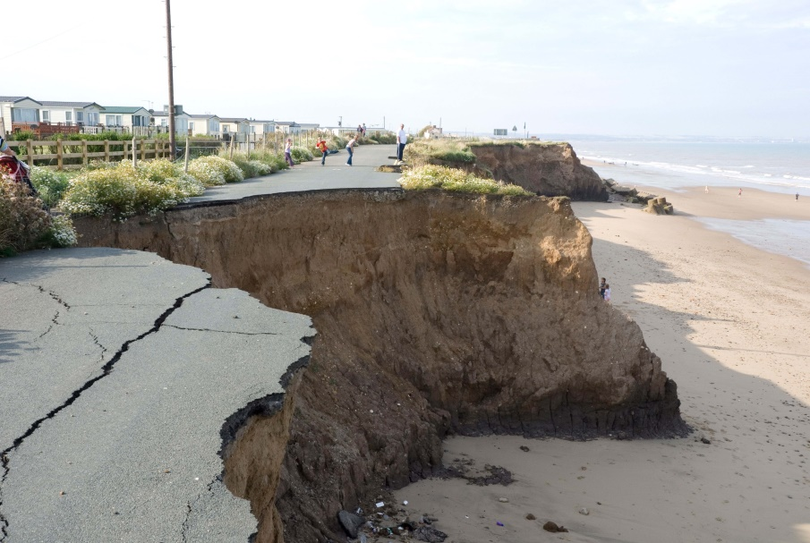

Write the events below in order to show how the above could have happened:

* Soil under cliff falls
* Population increase
* Topsoil erodes
* Less trees to hold soil together
* More houses built

a

b

c

d

e

3 Match the following engineering solution to the erosion problem.

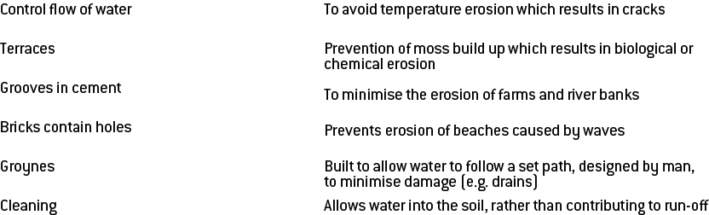

Word detective

4 Word search

Find the words listed, in the puzzle below.

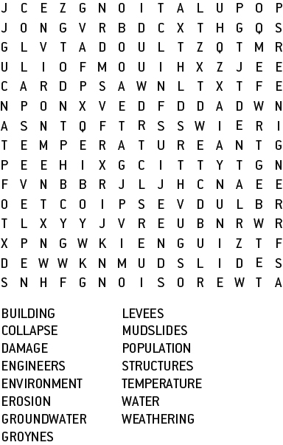

Literacy support worksheet answers

2.9 Rocks are studied by geologists

Pages 34–35 and 166-167

The work of geologists

1 How old is the Earth?

2 What is a fossil?

3 What kind of rocks are fossils found in?

4 How many years does it take to uncover a fossil?

5 When an organism is going to be fossilised, what can it be caught in?

a

b

6 What is working out whether rocks are younger or older called?

7 Draw a line to match the pictures with the descriptions below:

|  |  |
| --- | --- |
|  | Over millions of years, more sediment is deposited and the remains are gradually transformed into sedimentary rock. |
|  | Years of geological movement, weathering and erosion may eventually expose the fossil. |
|  | If an organism dies near water, it has a greater chance of being covered by sediment. |
|  | The sediment protects the body from predators and weathering. |

8 Fill in the gaps using the words below:

mammals fish shells

younger simple

Extremely old rocks contain fossils of \_\_\_\_\_\_\_\_\_\_\_\_\_\_\_\_\_\_\_ animals, whereas slightly

\_\_\_\_\_\_\_\_\_\_\_\_\_\_\_\_\_\_\_ rocks have fossils of animals with \_\_\_\_\_\_\_\_\_\_\_\_\_\_\_\_\_\_\_. Rocks that are younger

still have fossils of \_\_\_\_\_\_\_\_\_\_\_\_\_\_\_\_\_\_\_. Only the newest rocks have fossils of \_\_\_\_\_\_\_\_\_\_\_\_\_\_\_\_\_\_\_.

Word detective

9 Draw and label

Draw and label a diagram of comparative dating using the following words. Use Figure 2.46 in *Oxford Science 8 Western Australian Curriculum* to help you.

shale

limestone

oldest rock

conglomerate

shale

youngest rock